

**Splunk Integration For Databricks**

Installation And Usage Guide 1.2.0

Note:

This document is produced by Databricks as a reference. Databricks makes no warranties or guarantees. Information contained within may not be the most up-to-date available. Information in this document is subject to change without notice. Databricks shall not be liable for any damages resulting from technical errors or omissions that may be present in this document, or from use of this document.

Databricks and the Databricks logo are trademarks or service marks of Databricks, Inc. in the US and other countries. Microsoft Azure and Azure are trademarks of Microsoft Inc. Azure Databricks is a product provided by Microsoft, please see their website for additional information. All other trademarks within this document are property of their respective companies. Copyright 2022 Databricks, Inc. For more information, visit [http://www.databricks.com](http://www.databricks.com/).

Technical documentation and support materials include details based on the full set of capabilities and features of a specific release. Access to some functionality requires specific license types (tiers).

Version Control

| **#** | **Document**  **Version** | **Date** | **Owner** | **Document Status** | **Comments** |
| --- | --- | --- | --- | --- | --- |
| 1 | 1.0.0 | 27th Dec 2020 | Crest Data  Systems | Draft | Initial Draft |
| 2 | 1.1.0 | 7th February 2022 | Crest Data Systems | Draft | V 1.1.0 |
| 3 | 1.2.0 | 27th December 2022 | Crest Data Systems | Draft | V 1.2.0 |

**Overview** **4**

**Compatibility Matrix** **4**

**System Requirements** **5**

**Installation** **5**

**Configuration** **5**

Configure Proxy Details 6

Configure Databricks Credentials 7

Prerequisites for configuration via Azure Active Directory: 7

Configure Logging 10

**Executing custom commands** **11**

databricksquery 11

dbsubmitrun 12

dbexecutejob 13

databricksretiredrun 14

**Lookups** **15**

**Macro** **15**

**Saved Search** **15**

**Alert action** **17**

**Upgrade instructions** **18**

Upgrade from Databricks Add-On for Splunk v1.1.0 to v1.2.0 18

**Known Issues** **18**

**Limitations** **18**

**Troubleshooting** **19**

**Uninstall & Cleanup Steps** **20**

# Overview

Databricks is a unified data analytics platform used for processing and transforming massive quantities of data and exploring the data through machine learning models. It offers a data science workspace, SQL analytics, unified data service, and enterprise cloud services. For more details visit [here](https://databricks.com/product/unified-data-analytics-platform).

Splunk is a software platform that enables users to search, analyze, and visualize the data gathered from the components of their IT infrastructure or business. It takes in data from websites, applications, sensors, devices, and so on. After you define the data source, Splunk Enterprise indexes the data stream and parses it into a series of individual events that you can view and search. For more details visit [here](https://docs.splunk.com/Documentation/Splunk/8.1.1/Overview/AboutSplunkEnterprise).

With “Splunk Integration For Databricks”, users will be able to:

* Ingest their data present in Databricks delta table into Splunk
* Query their data present in Databricks delta table from Splunk
* Execute Databricks notebooks from Splunk

This integration will consist of mainly 2 things:

* A Splunk application that’ll manage authentication with Databricks, provide custom commands to submit queries and jobs in Databricks.
* A Databricks notebook using which users can push their data in the Databricks delta table to Splunk.

# Compatibility Matrix

| **Splunk Version** | **Operating System** | **Databricks Runtime** | **Databricks API Version** |
| --- | --- | --- | --- |
| 8.1 | CentOS, Ubuntu, Windows 10, Windows Server 2019 | 7.3 | * REST API 1.2 for command execution * REST API 2.0 for the rest of the features |
| 8.2 | CentOS, Ubuntu, Windows 10, Windows Server 2019 | 7.3 | * REST API 1.2 for command execution * REST API 2.0 for the rest of the features |
| 9.0 | CentOS, Ubuntu, Windows 10, Windows Server 2019 | 7.3 | * REST API 1.2 for command execution * REST API 2.0 for the rest of the features |

# System Requirements

The system requirements for the Splunk integration are the same as the basic requirements of the Splunk deployment. ([Reference](https://docs.splunk.com/Documentation/Splunk/8.0.0/Capacity/Referencehardware))

# Installation

Based on your Splunk deployment, follow the steps mentioned below to install the Splunk applications:

* [Standalone Splunk Deployment](https://docs.splunk.com/Documentation/AddOns/released/Overview/Singleserverinstall)
* [Distributed Splunk Deployment](https://docs.splunk.com/Documentation/AddOns/released/Overview/Distributedinstall)

In case of deployment in the search head cluster environment use a deployer to push the apps. Follow the below steps to push the apps to search head cluster members:

* On deployer node, extract the app at $SPLUNK_HOME$/etc/shcluster/apps.
* Create a “shclustering” stanza at path $SPLUNK_HOME$/etc/shcluster/apps/TA-Databricks/local/server.conf and add following information to the stanza: conf_replication_include.ta_databricks_settings = true as shown below.  
    
  [shclustering]  
  conf_replication_include.ta_databricks_settings = true
* Push the bundle to search head members

If you are using “Distributed Splunk Deployment”, refer to the below table to find where to install which applications:

| **Splunk Instance Type** | **Databricks Add-on for Splunk Required?** |
| --- | --- |
| Heavy Forwarder | - |
| Indexer/Indexer Cluster | - |
| Search Head/Search Head Cluster | Yes |

# Configuration

Users will be required to have databricks_admin role to configure Databricks Add-on for Splunk. Users with databricks_user role will only be able to view the configuration. Users who are not having either of the roles, for them the Configuration Page won't load and will not be able to run the Custom Commands also. This integration allows a user to configure multiple pair of Databricks Instance, its credentials and Databricks Cluster Name at a time. In case a user is using the integration in search head cluster environment, configuration on all the search cluster nodes will be overwritten

Once the installation is done successfully, follow the below steps to configure the app.

## Steps to assign databricks_admin role:

* Login as admin.
* Go to Settings->Users.
* If you want to create a new User: Click on "New User". Enter "Name" of the user, set and confirm password. In the Assign roles section select 'databricks_admin' role, it should be shown in Selected Items sections and Save. Go to Administrator and select Logout. Login as the User you created by giving the name and password. While logging as a new User created it will ask to reset password, Reset the password and complete login.
* If you want to edit an existing User: Click on Edit section in Actions of the User you want to update. In the Assign roles section select 'databricks_admin' role, it should be shown in Selected Items sections and Save. Go to Administrator and select Logout. Now Login as the user you created by entering username and password.

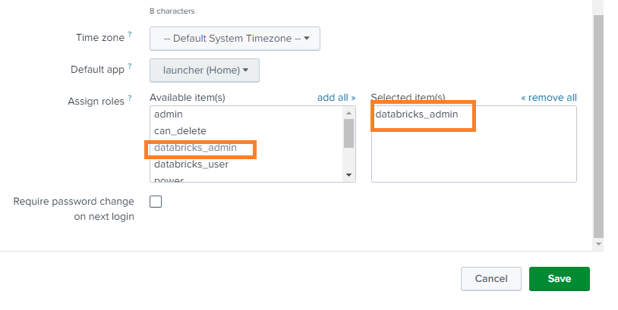

## Steps to assign databricks_user role:

* Login as admin.
* Go to Settings->Users.
* If you want to create a new User: Click on "New User". Enter "Name" of the user, set and confirm password. In the Assign roles section select 'databricks_user’' role, it should be shown in Selected Items sections and Save. Go to Administrator and select Logout. Login as the User you created by giving the name and password. While logging as a new User created it will ask to reset password, Reset the password and complete login.
* If you want to edit an existing User: Click on Edit section in Actions of the User you want to update. In the Assign roles section select 'databricks_user' role, it should be shown in Selected Items sections and Save. Go to Administrator and select Logout. Now Login as the user you created by entering username and password.

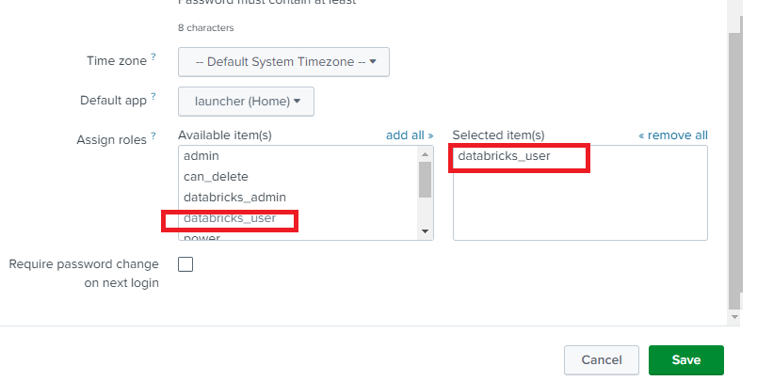

## 

## Configure Proxy Details

This step is only required if you want to use a proxy server. To configure proxy details:

* Log in to Splunk UI.
* Go to the Configuration page, either by clicking on the name of the add-on on the left navigation banner on the home page or by going to Manage Apps, then clicking Launch app in the row for Databricks Add-on for Splunk.
* Click the Configuration menu and in the Proxy tab, fill in the required details. Refer to the below table to fill in the details.

| **Input** | **Required** | **Description** |
| --- | --- | --- |
| Enable | Yes | Whether to use a proxy or not |
| Proxy Type | Yes | Type of proxy Options: http |
| Host | Yes | Proxy host |
| Port | Yes | Port to use |
| Username | No | Username to use for authentication |
| Password | No | Password for the provided username. |

* Click Save.

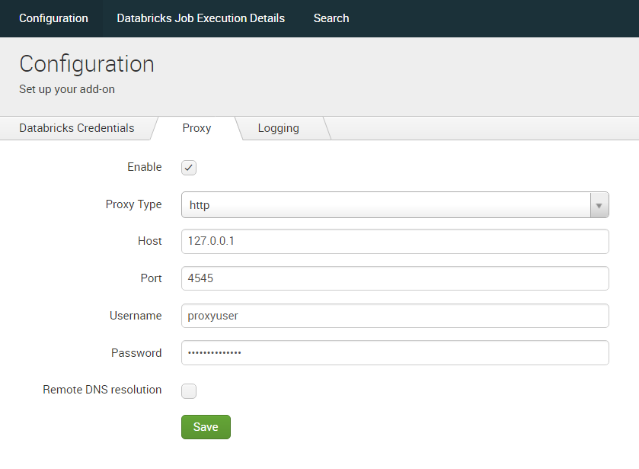

## Configure Databricks Credentials

User can authenticate using two ways:

* Using Personal access tokens
* Using Azure Active Directory Tokens

### **Prerequisites for configuration via Azure Active Directory:**

To configure the Add-on with Azure Active Directory, you need to provision a service principal in Azure Portal and add it to the target Azure Databricks workspace.

* To provision, a service principal, follow [these steps](https://docs.microsoft.com/en-us/azure/databricks/dev-tools/api/latest/aad/service-prin-aad-token#--provision-a-service-principal-in-azure-portal)
* When creating a client secret, the default Expiry time for the secret is six months. Six months after the creation of the secret, it will expire and no longer be functional. In this case, the user needs to create a new client secret and configure the Add-on again. Users can also set a custom expiration time larger than the default value while creating the secret. Example: 12 months
* To add the provisioned service principal to the target Azure Databricks workspace, follow [these steps](https://docs.microsoft.com/en-us/azure/databricks/dev-tools/api/latest/scim/scim-sp#add-service-principal) and refer to this [example](https://docs.microsoft.com/en-us/azure/databricks/dev-tools/api/latest/aad/service-prin-aad-token#--api-access-for-service-principals-that-are-azure-databricks-workspace-users-and-admins)

**Note:** The service principals must be Azure Databricks workspace users and admins.

To configure Databricks credentials:

* Log in to Splunk UI.
* Go to the Configuration page, either by clicking on the name of the add-on on the left navigation banner on the home page or by going to Manage Apps, then clicking Launch app in the row for Databricks Add-on for Splunk.
* Click the Configuration menu and in the Databricks Credentials tab click on Add, fill in the required details. Refer to the below tables to fill in the details.
  + If Authentication mechanism to be used is Personal access token

| **Input** | **Required** | **Description** |
| --- | --- | --- |
| Account Name | Yes | Unique name of the account. |
| Databricks Instance | Yes | URL of Databricks instance to be used. |
| Authentication Method | Yes | Databricks personal access token to use for authentication. |
| Databricks Access Token | Yes | Databricks personal access token to use for authentication when authentication method is “Personal Access Token” |

# 

* + If Authentication mechanism to be used is Azure Active Directory

| **Input** | **Required** | **Description** |
| --- | --- | --- |
| Account Name | Yes | Unique name of the account. |
| Databricks Instance | Yes | URL of Databricks instance to be used. |
| Authentication Method | Yes | Databricks personal access token to use for authentication. |
| Client Id | Yes | Azure AD Client ID. Required when authentication method is “Azure Active Directory” |
| Tenant Id | Yes | The application/tenant ID of the registered app in Azure AD you wish to use. Required when authentication method is “Azure Active Directory” |
| Client Secret | Yes | The client secret from Azure AD. Required when authentication method is “Azure Active Directory” |

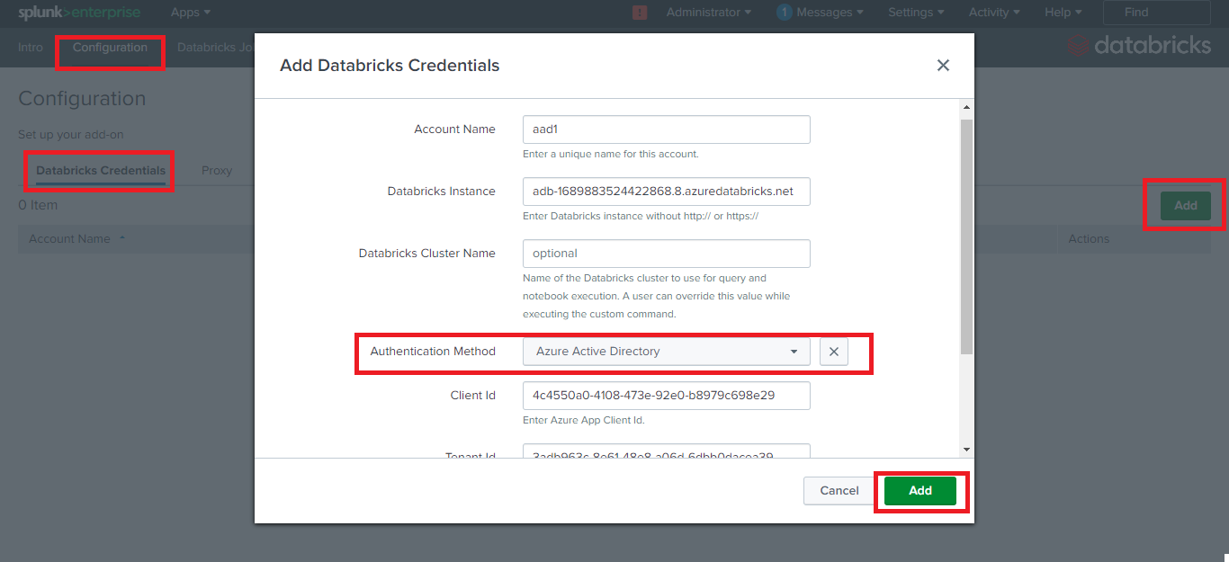

* Click Add.

**Note:** For validation of the parameters provided, the application will try to get the clusters present in the Databricks instance.

## 

## Configure Logging

To configure Logging:

* Log in to Splunk UI.
* Go to the Configuration page, either by clicking on the name of the add-on on the left navigation banner on the home page or by going to Manage Apps, then clicking Launch app in the row for Databricks Add-on for Splunk.
* Click on the Configuration menu and in the Logging tab, select appropriate Log Level from the dropdown.
* Click Save.

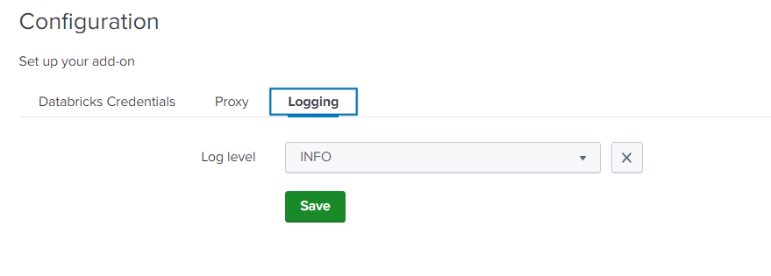

# Executing custom commands

Users will be required to have either a databricks_admin or databricks_user role in order to execute the custom commands.

Once the users configure Databricks Add-on for Splunk successfully, they can execute custom commands to

* Query their data present in the Databricks table from Splunk.
* Execute Databricks notebooks from Splunk.

Currently, Databricks Add-on for Splunk provides four custom commands. Users can open the Splunk search bar and can execute the commands. Below are the command details.

## databricksquery

This custom command helps users to query their data present in the Databricks table from Splunk.

* **Command** **Parameters**

| **Parameter** | **Required** | **Overview** |
| --- | --- | --- |
| account_name | Yes | Configured account name. |
| cluster | Yes | Name of cluster you want to query data from |
| query | Yes | SQL query to get data from Databricks delta |
| command_timeout | No | Timeout for command execution in seconds. Default to 300 seconds |

* **Syntax**  
    
  *| databricksquery account_name=”<account_name>” cluster=”<cluster_name>” query=”<SQL query>” command_timeout=<timeout_in_seconds> | table \**
* **Output**The command will give the output of the query in tabular format. It will return an error message in case any error occurs during query execution.
* **Example**| databricksquery *account_name=”aad1”* cluster=”Crest Cluster1” query="SELECT * FROM hive_metastore.default.people_csv" command_timeout=60 | table *

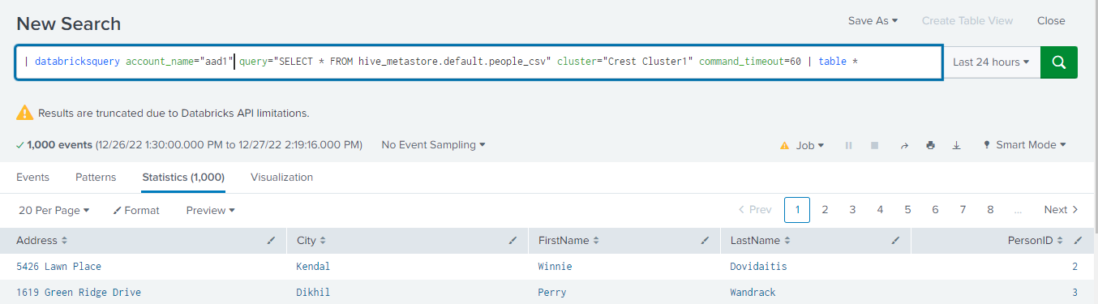

## databricksrun

This custom command helps users to submit a one-time run without creating a job.

* **Command Parameters**

| **Parameter** | **Required** | **Overview** |
| --- | --- | --- |
| account_name | Yes | Configured account name. |
| run_name | No | Name of the submitted run |
| cluster | Yes | Name of cluster you want to run notebook on |
| notebook_path | Yes | The absolute path of the notebook to be run in the Databricks workspace. This path must begin with a slash. This field is required. |
| revision_timestamp | No | The timestamp of the revision of the notebook. |
| notebook_params | No | Parameters to pass while executing the run. In the form of “key1=value1||key2=value2||...” |

* **Syntax**  
    
  | databricksrun account_name="<account_name>" notebook_path="<path_to_notebook>" run_name="<run_name>" cluster="<cluster_name>" revision_timestamp=<revision_timestamp> notebook_params="<params_for_job_execution>" | table *

* **Output**

The command will give the details about the executed run through the job.

* **Example**

| databricksrun account_name="account_name" notebook_path=”/path/to/test_notebook” cluster="test_cluster" notebook_params=”key1=value1||key2=value2” | table *

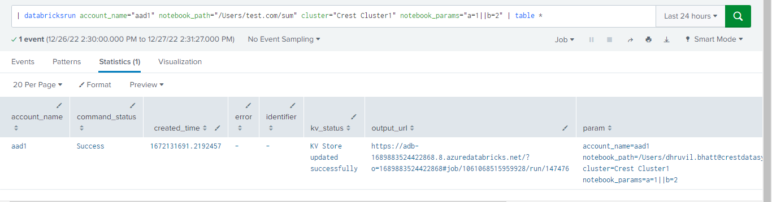

## databricksjob

This custom command helps users to run an already created job now from Splunk.

* **Command Parameters**

| **Parameter** | **Required** | **Overview** |
| --- | --- | --- |
| account_name | Yes | Configured account name. |
| job_id | Yes | Job ID of your existing job in Databricks |
| notebook_params | No | Parameters to pass while executing the job. In the form of “key1=value1||key2=value2||...” |

* **Syntax**  
    
  *| databricksjob account_name="<account_name>" job_id=<job_id> notebook_params="<params_for_job_execution>" | table \**
* **Output**  
    
  The command will give the details about the executed run through the job.
* **Example**| databricksjob account_name="account_name" job_id=2 notebook_params="key1=value1||key2=value2" | table *

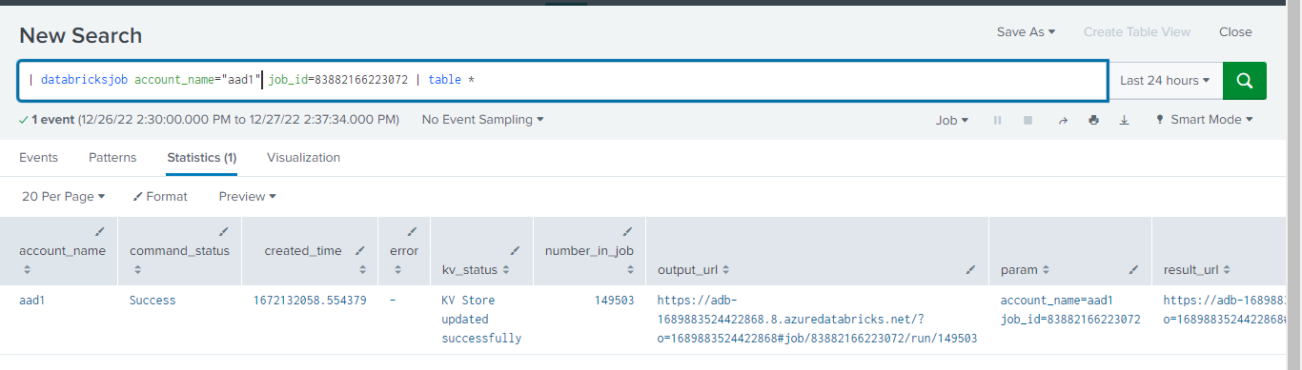

## databricksretiredrun

This command is used to delete the records based on the provided parameter from the submit_run_logs lookup, which maintains the details of notebook runs. To run the command at least one of the parameters is required. When all parameters are provided, it will delete the records matching all the parameters together.

* **Command parameters**

| **Parameter** | **Required** | **Overview** |
| --- | --- | --- |
| account_name | Yes | Configured account name. |
| days | No | The number of days, records older than which will be deleted from submit_run_log lookup |
| run_id | No | ID of the submitted run. |
| user | No | Name of an existing splunk user. |

* **Syntax**  
  *| databricksretiredrun account_name=”<account_name>” days="<number_of_days>" run_id="<run_id>" user="<user_name>"*
* **Output**The command will delete the details of notebook runs from submit_run_log lookup.
* **Example 1**  
  | databricksretiredrun *account_name=”<account_name>”* days=90
* **Example 2**  
  | databricksretiredrun *account_name=”<account_name>”* user="john doe"
* **Example 3**  
  | databricksretiredrun *account_name=”<account_name>”* run_id="12344"
* **Example 4**  
  | databricksretiredrun *account_name=”<account_name>”* days=90 user="john doe" run_id="12344"

# Lookups

The Add-on contains two KV store lookups :**submit_run_logs** and **execute_job_logs** that store the details of the Notebooks and jobs run using commands **databricksrun** and **databricksjob** respectively.

# Macro

Macro **databricks_run_retiring_days** specifies the days, records older than which will be deleted from submit_run_log lookup using saved search **databricks_retire_run**. The default value configured is 90 days.

To modify Macro from Splunk UI,

1. Go to **Setting** -> **Advanced** **search** -> **Search** **Macros**.

2. Select **Databricks** **Add-on** **for Splunk** in the App context.

3. Configure the macro by clicking on the **Name** of the Macro, go to the **Definition** field and update it as per requirements.

# Saved Search

Saved search **databricks_retire_run** uses the databricksretiredrun command to delete the records older than days specified in macro **databricks_run_retiring_days** from the **submit_run_logs** lookup. By default, it is invoked once every day at 1:00 hrs and deletes records older than 90 days. The **databricks_run_retiring_days** can be modified to change the default 90 days.

Dashboards

The dashboard will be accessible to all the users. A user with admin_all_objects capability can navigate to “<splunk_instance_host_or_ip>:<splunk_web_port>/en-US/app/TA-Databricks/dashboards” to modify the permissions for dashboards.

This app contains the following dashboards

**Databricks Job Execution Details:**

The dashboard provides the details about the one-time runs and jobs executed using databricksrun and databricksjob custom commands respectively.

The dashboard uses the following parameters from user

| **Parameter** | **Required** | **Overview** |
| --- | --- | --- |
| Creation Time Filter | Yes | Time range when the job/notebook was run. |
| Submission status | Yes | Status of the job/run .  Values: Failed, success, All  default: All |
| User Filter | Yes | Name of an existing Splunk use who ran the job/run  default: All |

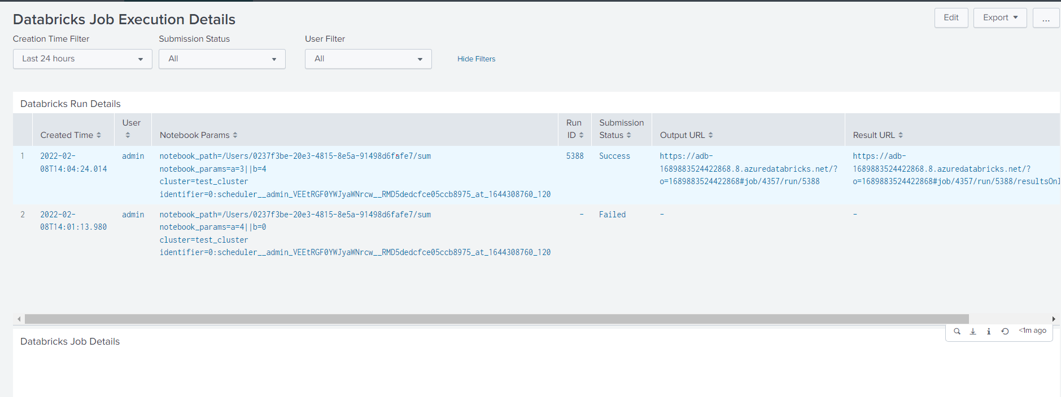

**Launch Notebook:**

The dashboard allows users to execute a notebook on their Databricks cluster by providing the required parameters. The users can then navigate to the results page on the Databricks instance using the link in the dashboard panel.

The dashboard uses the following parameters from user

| **Parameter** | **Required** | **Overview** |
| --- | --- | --- |
| Notebook Path | Yes | The absolute path of the notebook to be run in the Databricks workspace. This path must begin with a slash. |
| Notebook revision timestamp | No | The timestamp of the revision of the notebook. |
| Notebook Parameters | No | Parameters to pass to the notebook. In the form of “key1=value1||key2=value2||...” |
| Cluster Name | No | Name of cluster you want to run the notebook on. |
| Account Name | Yes | Configured account name. |
| Auto Forward | Yes | Yes - If you directly want to be redirected to the Databricks result URL  No - If you want to manually redirect to the Databricks URL by clicking on the URL hyperlink. This is the default selection. |

You can refer to the **Launching a Notebook through dashboard** panel in the Intro dashboard for example after the app installation.

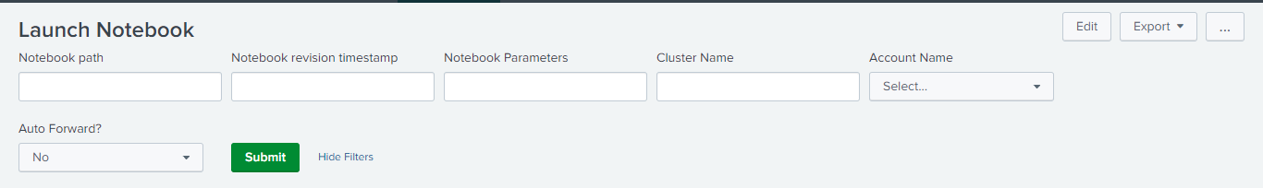

# Alert action

The **Launch Notebook** alert action is used to execute a parameterized notebook based on the provided parameters. The alert can be scheduled or run as ad-hoc. It can also be used as Adaptive response action in "**Enterprise Security> Incident Review dashboard**".

When this alert action is run as Adaptive response action from "**Enterprise Security > Incident review dashboard**", a launch_notebook link will be visible in the Adaptive Responses table in the Incident review dashboard which will redirect to the Launch Notebook dashboard with parameters.

You can refer to the **Launching Notebook through Adaptive Response** panel in the Intro dashboard for example after the app installation.

**Note**:

* The redirection will work properly only when the status is in Sucess state.
* Once the Adhoc-Alert action is run from the "**Enterprise Security > Incident review dashboard**", in Adhoc mode, you will need to refresh and check for status update.

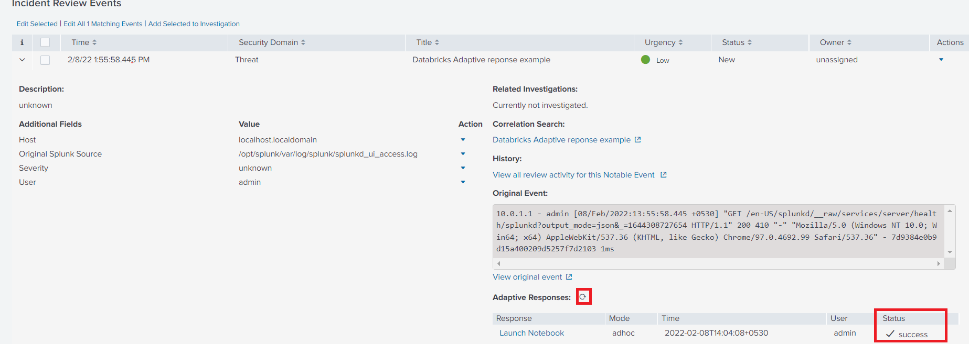

# Upgrade instructions

### General upgrade steps:

* Log in to Splunk Web and navigate to Apps -> Manage Apps.
* Click Install app from file.
* Click Choose file and select the Databricks Add-on for Splunk installation file.
* Check the Upgrade checkbox.
* Click on Upload.
* Restart Splunk.

### Upgrade from Databricks Add-On for Splunk v1.1.0 to v1.2.0

* Follow the below steps to upgrade the Add-on to 1.2.0
  + Follow the General upgrade steps section.
  + Navigate to Settings > Users.
  + Create new user or provide existing user with "databricks_admin" role.
  + Login with the user having "databricks_admin" role.
  + Navigate to Databricks Add-on for Splunk > Configuration.
  + Click on Add button, and reconfigure account with required information.
  + The logged in user will now able to execute any custom commands.

**Note**: Create new user or provide existing user with "databricks_user" role in order to restrict them from configuring/modifying the credentials.

# Known Issues

* When the commands fail, sometimes an indistinct/unclear error message is displayed in UI, not giving a precise reason for the failure. To troubleshoot such cases, please check the logs at $SPLUNK_HOME/var/log/TA-Databricks/<command_name>_command.log to get the precise reason for the failure.
* When the Adaptive response action `Launch Notebook` is run more than once for the same notable event in Enterprise Security security, clicking on any of the `launch_notebook` links will redirect to the Launch Notebook dashboard with the latest run details.

# Limitations

* The Databricks API used in the `databricksquery` custom command has a limit on the number of results to be returned. Hence, sometimes the results obtained from this custom command may not be complete.

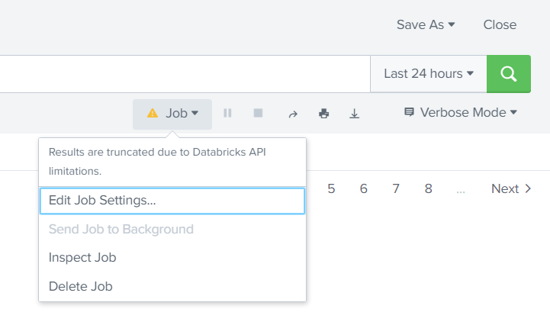

# Troubleshooting

* Instance URL should not start with scheme: Provide a Databricks instance without HTTP/HTTPS scheme. HTTPS scheme will be hard-coded before making any network calls.
* Unable to request Databricks instance. Please validate the provided Databricks and Proxy configurations or check the network connectivity.
* Configuration page failed to load, the server reported internal errors which may indicate you do not have access to this page.
* b'{"messages":[{"type":"ERROR","text":"You (user=databricks_user) do not have permission to perform this operation (requires capability: $db_write_conf$)."}]}'
* Lack of "databricks_user" role for the current user. Refer to the "Provide Required Access" section in the Intro page.
* Invalid access token. Please enter the valid access token: Provided Access token is not a valid token. Please verify the token.
* Addon is not configured. Navigate to addon's configuration page to configure the addon.
* Error in SQL statement. AnalysisException. Table or view not found: You have entered invalid table name or invalid database name.
* API limit exceeded. Please try again after some time: You have made too many requests and the API limit has been exceeded.
* MaxContextException: Too many execution contexts are open right now: You have requested too many executions. Please try again after some time.
* Ensure that the cluster is in the running state. Current cluster state is {Terminated/Pending}
* No cluster found with name {cluster_name}. Provide a valid cluster name.
* Given job does not contain the notebook task. Hence terminating the execution.
* Databricks cluster is required to execute this custom command. Provide a cluster parameter or configure the cluster in the TA's configuration page.
* Could not complete the query execution. Status {Cancelled/Error}: Submitted SQL query could not complete the execution on Databricks instance and returned error.
* Encountered unknown result type, terminating the execution: The SQL query returned something else other than the tabular result, which cannot be parsed by Splunk.
* Command execution timed out: The SQL query could not return anything. Try re-running the command after increasing the value for command_timeout parameter.
* Authentication Failure: Check the network connectivity and verify that the details provided for the authentication mechanism are correct.
* The Add-on does not require a restart after the installation for all functionalities to work. However, the icons will be visible after one Splunk restart post-installation.
* If all custom commands/notebooks fail to run with HTTPS response code [403] then most probably the client secret has expired. Please regenerate your client secret in this case on your Azure portal and configure the add-on again with the new client secret. Set the client secret's expiration time to a custom value that you see fit. Refer to this [guide](https://docs.microsoft.com/en-us/azure/active-directory/develop/quickstart-register-app#add-a-client-secret) for setting a client secret in Azure Active Directory.
* For any other unknown failure, please check the log files $SPLUNK_HOME/var/log/ta_databricks*.log to get more details on the issue.

# Uninstall & Cleanup Steps

* Remove $SPLUNK_HOME/etc/apps/TA-Databricks/
* Remove $SPLUNK_HOME/var/log/TA-Databricks/
* Remove $SPLUNK_HOME/var/log/splunk/**ta_databricks*.log**
* To reflect the cleanup changes in UI, restart Splunk instance. Refer to [Start
* Splunk](https://docs.splunk.com/Documentation/Splunk/8.0.6/Admin/StartSplunk) documentation to get information on how to restart Splunk.

**Note**: $SPLUNK_HOME denotes the path where Splunk is installed. Ex: /opt/splunk

# 